PROJECT MANAGEMENT PLAN
  - Carpenters Car Rental and Equipment Maintenance System (CREMS)
  - Semester 2, 2026


CARPENTERS FIJI PTE LIMITED
CS400 Industry Experience Project
Academic supervisor: Dr Ravneil Nand

Group 10
Name | Student ID
Kavish Chandra | S11219143
Shoneel Kumar | S11219651
Sudhansu Kisun | S11219520
Rahul Chand | S11219885

Table of Contents
1.0 Introduction 1
2.0 Project Management Approach 2
3.0 Project Scope 3
3.1 In-Scope Divisions and Services 3
3.2 In-Scope Shared Capabilities 3
3.3 Out of Scope for The MVP 3
4.0 Milestone 4
5.0 Schedule Baseline 5
6.0 Work Breakdown Structure (WBS) 6
6.1 WBS Definition Table 6
6.1 Graphical Representation of WBS 9
6.3 Weekly Sprint Cadence 9
7.0 Change Management Plan 10
7.1 Change Request Form 10
8.0 Communications Management Plan 11
8.1 Project Team Directory 11
8.2 Communications Conduct 12
9.0 Cost Management Plan 13
9.1 Cost Baseline 13
9.2 Cost Reporting and Roles 14
10.0 Procurement Management Plan 15
11.0 Project Scope Management Plan 16
12.0 Schedule Management Plan 17
12.1 Scheduling Methodology and Tools 17
12.2 Schedule Development 17

13.0 Quality Management Plan 18
13.1 Quality Metrics 18
13.2 Quality Assurance Activities (Process-Focused) 19
13.3 Quality Control Activities (Product-Focused) 20
14.0 Risk Management Plan 21
14.1 Risk Management Approach 21
14.2 Risk Register 21
14.3 Top Risks Summary 25
15. Resource Calendar 26
15.1 Human Resources 26
15.2 Technical and Information Resources 26
16.0 Reference 27
17.0 Appendix 28
17.1 Appendix A 28
17.2 Appendix B 29
17.3 Appendix C 30
17.4 Appendix D 31
17.6 Appendix F 31
18.0 Sponsor Acceptance 32

1.0 Introduction

The Carpenters Rental & Asset Management System (CREMS) is proposed as a modular web-based platform for managing rentable assets across Carpenters Fiji. The approved initial implementation scope covers Carpenters Motors and Carptrac. The system will use a configurable architecture that supports the controlled addition of future divisions without redesigning the modules. The common business thread is the complete asset rental and maintenance lifecycle rather than the broader operations of either division.
CREMS will provide a shared control point for registering and locating assets, checking availability, managing customers and bookings, recording pre-hire and post-hire inspections, logging damage, scheduling preventive and corrective maintenance, and reporting revenue and expenditure at asset level. Division, branch and role boundaries will ensure users see only the work relevant to them while common modules can be configured for future divisions.
The project will be delivered through twelve one-week sprints from 10 August to 30 October 2026. Week 1 finalizes requirements and scope while establishing the shared repository and initial database foundation. Week 2 begins authentication, session security, and startup system services. Later sprints deliver organization, customer, asset, pricing, booking, inspection, maintenance and reporting modules in a dependency-aware sequence. The team will demonstrate increments regularly and maintain traceability from approved requirements to implementation and test evidence.

2.0 Project Management Approach

CREMS is delivered under an agile operating model led by the project leader, who holds overall authority and responsibility for managing and executing the project according to this plan and the team charter. The project team consists of four student developers who each take a functional lead role while retaining collective ownership of the codebase; members pair on higher-risk features, review one another's changes, and rotate meeting-note, demonstration and support duties.
Delivery runs in weekly sprints inside a twelve-week program. Each sprint begins with planning and acceptance-criteria confirmation, proceeds through development and peer review. [8], [9]

3.0 Project Scope

3.1 In-Scope Divisions and Services
Division / area | Assets and services in the initial scope | Division-specific considerations
Carpenters Motors | Rental vehicles, including passenger and commercial vehicles | Vehicle registration, odometer, fuel, driver details, vehicle inspection and daily rates
Carptrac CAT | Forklifts, cranes, excavators, generators and related hire equipment | Engine hours, qualifications, operator assignment, overtime, safety checks and hourly/daily rates
Carpenters Shipping | Portable toilets (portaloos), large metal bins and scaffolding available for hire | Delivery and collection scheduling, site location, quantity tracking, condition inspections, transport and labor costs, recurring servicing for portable toilets, and daily/weekly/monthly hire rates

3.2 In-Scope Shared Capabilities
- Secure customer and staff authentication with role, division, and branch-based access.
- Customer registration, corporate/individual profiles, contacts and approved renters.
- Asset master data, status history, QR/barcode, meter readings, and lifecycle events.
- Availability search, quotation, booking/reservation, configurable charges, deposit and optional approvals.
- Rental agreement generation, customer acceptance, staff approval, invoice/quotation delivery by email.
- Allocation, delivery/collection where applicable, operator assignment and return processing.
- Pre-hire and post-hire checklists, photos, signatures, and damage reports.
- Preventive and corrective maintenance, reminders, parts/labor/contractor costs and downtime.
- Dashboards and reports for availability, rentals, overdue items, utilization, maintenance and asset profitability.
- Audit logging and configurable business notifications.
CREMS future ready scope will support new divisions through configuration of division and branch records, asset categories, custom field definitions, meter types, rate units, optional charges, checklist templates, approval stages and document requirements. Adding an operational division remains a controlled future increment with its own validation and UAT.

3.3 Out of Scope for The MVP
- Full accounting/ERP replacement, payroll, human resources management, and banking reconciliation.
- Live telematics/GPS vendor integration, advanced route optimization, and native offline mobile applications.
- Production payment gateway and third-party identity integration unless separately approved.
- Historical data migration beyond an agreed representative pilot dataset.

4.0 Milestone
The milestone list below reflects the delivery baseline confirmed with the client on 10 August 2026: a twelve-week program running from 10 August to 30 October 2026. If a milestone or delivery date risks slipping, the project leader will immediately take proactive measures; any approved change to a milestone is communicated to the whole team and the client through the change control process.
Milestone | Sprint | Definition of done
M1 — Scope and engineering foundation | Week 1 | Approved Motors/Carptrac boundary; repository and initial database baseline in place
M2 — Secure sign-in demo | Week 2 | Staff/customer sign-in, secure password handling, session timeouts and API authorization default demonstrated
M3 — Access-isolation demo | Week 3 | Division/branch/role administration and API-level isolation demonstrated
M4 — Configurable asset-register demo | Week 5 | Categories, dynamic attributes, QR/barcode and status history demonstrated for both divisions' asset types
M5 — Quotation-to-booking demo | Week 7 | Booking conversion, approvals, agreement generation and notifications demonstrated
M6 — Motors lifecycle demo | Week 8 | End-to-end Motors scenario: availability → booking → pre-hire → QR check-out → return → post-hire demonstrated
M7 — Carptrac lifecycle demo | Week 10 | End-to-end Carptrac scenario including operator assignment and engine-hour tracking demonstrated
M8 — Final handover | Week 12 | Stabilization complete; deployment/runbook, user/admin guides, final report/presentation and acceptance delivered

5.0 Schedule Baseline
The schedule uses weekly increments so client feedback can refine the solution without losing control of scope. Each sprint ends with a review, evidence update and prioritized backlog. [9]
Week / dates | Primary focus | Planned outputs / milestone
1 | 10-14 Aug | Scope, repository and database foundation | Client meeting notes; domain research; approved Motors/Carptrac boundary; requirements and risks; Git repository/branch conventions; solution skeleton; initial SQL Server container, DbContext and baseline migration.
2 | 17-21 Aug | Authentication and startup system services | Staff/customer sign-in; secure password handling; cookie/session timeouts; API authorization default; health checks; error handling; configuration and audit foundations.
3 | 24-28 Aug | Organization, divisions, branches, roles and permissions | Division/branch administration; user assignments; role matrix; API-level division and branch isolation; configuration screens.
4 | 31 Aug-4 Sep | Customer module | Individual/corporate profiles; contacts; approved renters; documents; customer portal foundation; validation and search.
5 | 7-11 Sep | Flexible asset module | Categories; dynamic attribute definitions/values; Motors and Carptrac templates; branch/location/status history; meters; QR/barcode; asset detail.
6 | 14-18 Sep | Availability, rates and quotations | Conflict-aware calendar; hourly/daily/per-unit rate configuration; customer/division/branch rates; extra charges, deposits, discounts, tax and quote revisions.
7 | 21-25 Sep | Bookings, approvals, agreements and notifications | Booking conversion; configurable approval stages; agreement/document generation; booking email and status tracking.
8 | 28 Sep-2 Oct | Pre-hire, QR check-out, return and post-hire inspection | Checklist templates; photos/signatures; meter/fuel/accessories; allocation; QR handover; post-hire comparison and damage initiation.
9 | 5-9 Oct | Maintenance, damage and detailed expenditure | Preventive/corrective jobs; date/meter triggers; parts/labor/contractor costs; downtime; damage recovery; return-to-service controls.
10 | 12-16 Oct | Carptrac personnel and equipment-hire variations | Operator qualifications/availability; assignments; timesheets; engine hours; overtime; safety evidence; transport/service charges.
11 | 19-23 Oct | Dashboards, profitability, integration and UAT | Role dashboards; revenue/expense/profit; utilization and maintenance reports; alerts; authorization, timeout, calculation, migration, integration and UAT testing.
12 | 26-30 Oct | Stabilization, handover and closure | Critical fixes; performance/security checks; deployment/run book; user/admin guides; final report/presentation; acceptance and retrospective.

6.0 Work Breakdown Structure (WBS)

6.1 WBS Definition Table
WBS ID | Deliverable / Work Package | Scope Description | Expected Output | Week | Milestone / Assessment
1.0 | CARPENTERS RENTAL AND EQUIPMENT MANAGEMENT SYSTEM (CREMS) | Secure, modular rental, asset-tracking and maintenance-management system for Carpenters Motors and Carptrac. | Approved CREMS solution | Wk4–16 | Whole project
1.1 | Project Management | Management and control of project scope, time, risks and changes. | Approved plans and control records | Wk4–16 (ongoing) | —
1.1.1 | Requirements baseline | Confirm functional, non-functional and business requirements with the client. | Validated requirements specification | Wk5 | —
1.1.2 | Project plan | Document scope, WBS, schedule, resources, communication, quality and risks. | Approved project management plan | Wk4 | Project Proposal — 15%
1.1.3 | Sprint management | Plan, review, and record weekly incremental work. | Sprint plans, reviews and logs | Wk8–13 | —
1.1.4 | Risk & change control | Identify risks, manage issues and control requested scope changes. | Risk, issue and change registers | Wk4–16 | —
1.2 | Analysis & Design | Business, data, technical and interface designs for the proposed solution. | Approved system design package | Wk5–7 | —
1.2.1 | Process models | Model rental, inspection, approval, return and maintenance workflows. | Use cases and DFDs | Wk5 | —
1.2.2 | System architecture | Define the React, ASP.NET Core API and SQL Server architecture. | Architecture diagram and specification | Wk6 | —
1.2.3 | Database design | Define entities, relationships, constraints and data-isolation rules. | ERD and normalized schema | Wk6 | —
1.2.4 | UI & wireframes | Design responsive public, customer and role-specific staff interfaces. | Validated wireframes | Wk7 | Design Document complete
1.3 | Core Platform | Secure platform services shared by all CREMS modules. | Operational platform foundation | Wk8, Wk13 | Mid-Term Review — 20%
1.3.1 | Authentication | Provide staff and customer login, recovery and secure sessions. | Authentication service | Wk8 | Mid-Term Review — 20%
1.3.2 | Roles & permissions | Control role, permission, division and branch access. | Access-control framework | Wk8 | Mid-Term Review — 20%
1.3.3 | Divisions & branches | Configure divisions, branches, services and staff scopes. | Organization configuration module | Wk8–9 | —
1.3.4 | Security, audit & email | Protect APIs, enforce timeouts and record critical activity; deliver secure email notifications and track delivery. | Security controls, audit trail, and notification service | Wk8, Wk13 | —
1.4 | Asset Management | Complete operational and financial register for rentable assets. | Asset-management module | Wk9, Wk11–13 | —
1.4.1 | Asset register | Record identification, ownership, location, status, photographs and documents. | Searchable asset register | Wk9 | —
1.4.2 | Categories & attributes | Configure fields for vehicles, forklifts, excavators and future asset types. | Flexible category builder | Wk9 | —
1.4.3 | QR, meters & inspections | Generate and scan QR codes for rapid asset identification; capture inspections, odometers, operating hours and fuel readings. | QR identification workflow and inspection/meter history | Wk12 | —
1.4.4 | Lifecycle & profitability | Track commissioning, availability, hire, maintenance and retirement; calculate utilization, revenue, cost, profit and cost per usage unit. | Asset lifecycle history and performance dashboard | Wk11, Wk13 | —
1.5 | Customer Management | Individual and corporate customer records with controlled portal access. | Customer-management module | Wk9–11 | —
1.5.1 | Registration | Capture contact, identification, eligibility and account status. | Verified customer profile | Wk9 | Asset & customer master data demo
1.5.2 | Individual accounts | Provide a simple vehicle-rental customer experience. | Individual customer workflow | Wk9 | —
1.5.3 | Corporate accounts | Support contacts, purchase orders, credit controls and negotiated rates. | Corporate account controls | Wk9 | —
1.5.4 | Customer portal | Provide bookings, quotations, agreements, invoices and status tracking. | Authenticated customer portal | Wk9–11 | —
1.6 | Rental Management | End-to-end workflow from availability search to completed return. | Rental-management module | Wk10–11 | —
1.6.1 | Availability & requests | Detect booking, maintenance, inspection and allocation conflicts; review, allocate, confirm, cancel and track customer requests. | Availability calendar/validation and booking work queues | Wk10 | Live booking & availability demo
1.6.2 | Pricing & quotations | Calculate rates, operator, transport, deposit, discount and VAT. | Versioned customer quotations | Wk10–11 | —
1.6.3 | Approvals | Configure stages, limits, approvers, escalation and decisions. | Audited approval workflow | Wk10 | —
1.6.4 | Pickup, active hire & return | Verify requirements, inspect, sign, generate PDF and check out asset; monitor pickups, active hires, due dates, overdue items and incidents; inspect, assess charges, invoice and determine the asset's next status on return. | Signed agreement, hire operations workspace, and completed return with final invoice | Wk11 | Full rental lifecycle demo
1.7 | Maintenance Management | Preventive and corrective maintenance across all supported assets. | Maintenance-management module | Wk12–13 | —
1.7.1 | Maintenance requests | Register faults, damage and maintenance jobs. | Prioritized maintenance jobs | Wk12 | Inspections, maintenance & QR demo
1.7.2 | Preventive maintenance | Schedule work by date, kilometers or operating hours. | Preventive schedules and reminders | Wk12 | Inspections, maintenance & QR demo
1.7.3 | Maintenance costs | Capture parts, labor, suppliers, transport and contractor costs. | Detailed maintenance cost record | Wk12–13 | —
1.7.4 | Return to service | Verify completed work, downtime and operational readiness. | Approved return-to-service record | Wk12 | —
1.8 | Finance & Reporting | Financial transactions and management information. | Finance and reporting module | Wk11, Wk13 | —
1.8.1 | Invoices & payments | Manage invoices, deposits, payments, refunds and balances. | Customer financial records | Wk11, Wk13 | —
1.8.2 | Role dashboards | Provide relevant views for officers, managers, finance and administrators. | Role-specific dashboards | Wk13 | Full dashboard & reporting demo
1.8.3 | Operational reports | Report rental history, utilization, maintenance and overdue rentals. | Operational report suite | Wk13 | Full dashboard & reporting demo
1.8.4 | Financial reports | Report revenue, expenditure, asset profitability and margins. | Management financial reports | Wk13 | Full dashboard & reporting demo
1.9 | Testing & Acceptance | Verification that the delivered system meets approved requirements. | Tested and accepted system | Wk14–15 | —
1.9.1 | Unit & API testing | Verify business rules, calculations and API behaviour. | Automated test results | Wk8–14 | —
1.9.2 | Security testing | Verify authentication, authorization, isolation and sessions. | Security test evidence | Wk14 | Integration test report
1.9.3 | System testing | Test complete booking, hire, return and maintenance workflows. | System test report | Wk14 | Integration test report
1.9.4 | User acceptance testing | Run client scenarios, record feedback and correct issues. | Client acceptance record | Wk15 | UAT sign-off report
1.10 | Deployment & Closure | Release, documentation, training and formal project completion. | Deployed and handed-over system | Wk16-17 | Final Review — 30% / Practical Assessment — 25%
1.10.1 | Production environment | Configure the frontend, API, database, email, secrets and backups. | Production-ready environment | Wk16 | —
1.10.2 | Data preparation | Prepare initial divisions, branches, users, assets and settings. | Validated initial dataset | Wk16 | —
1.10.3 | Documentation & training | Prepare user, administrator, installation and technical guides. | Documentation and training package | Wk16 | Final Review — 30%
1.10.4 | Handover & sign-off | Demonstrate the system and deliver code and documents. | Final client sign-off | Wk17 | Practical Assessment — 25%

6.1 Graphical Representation of WBS
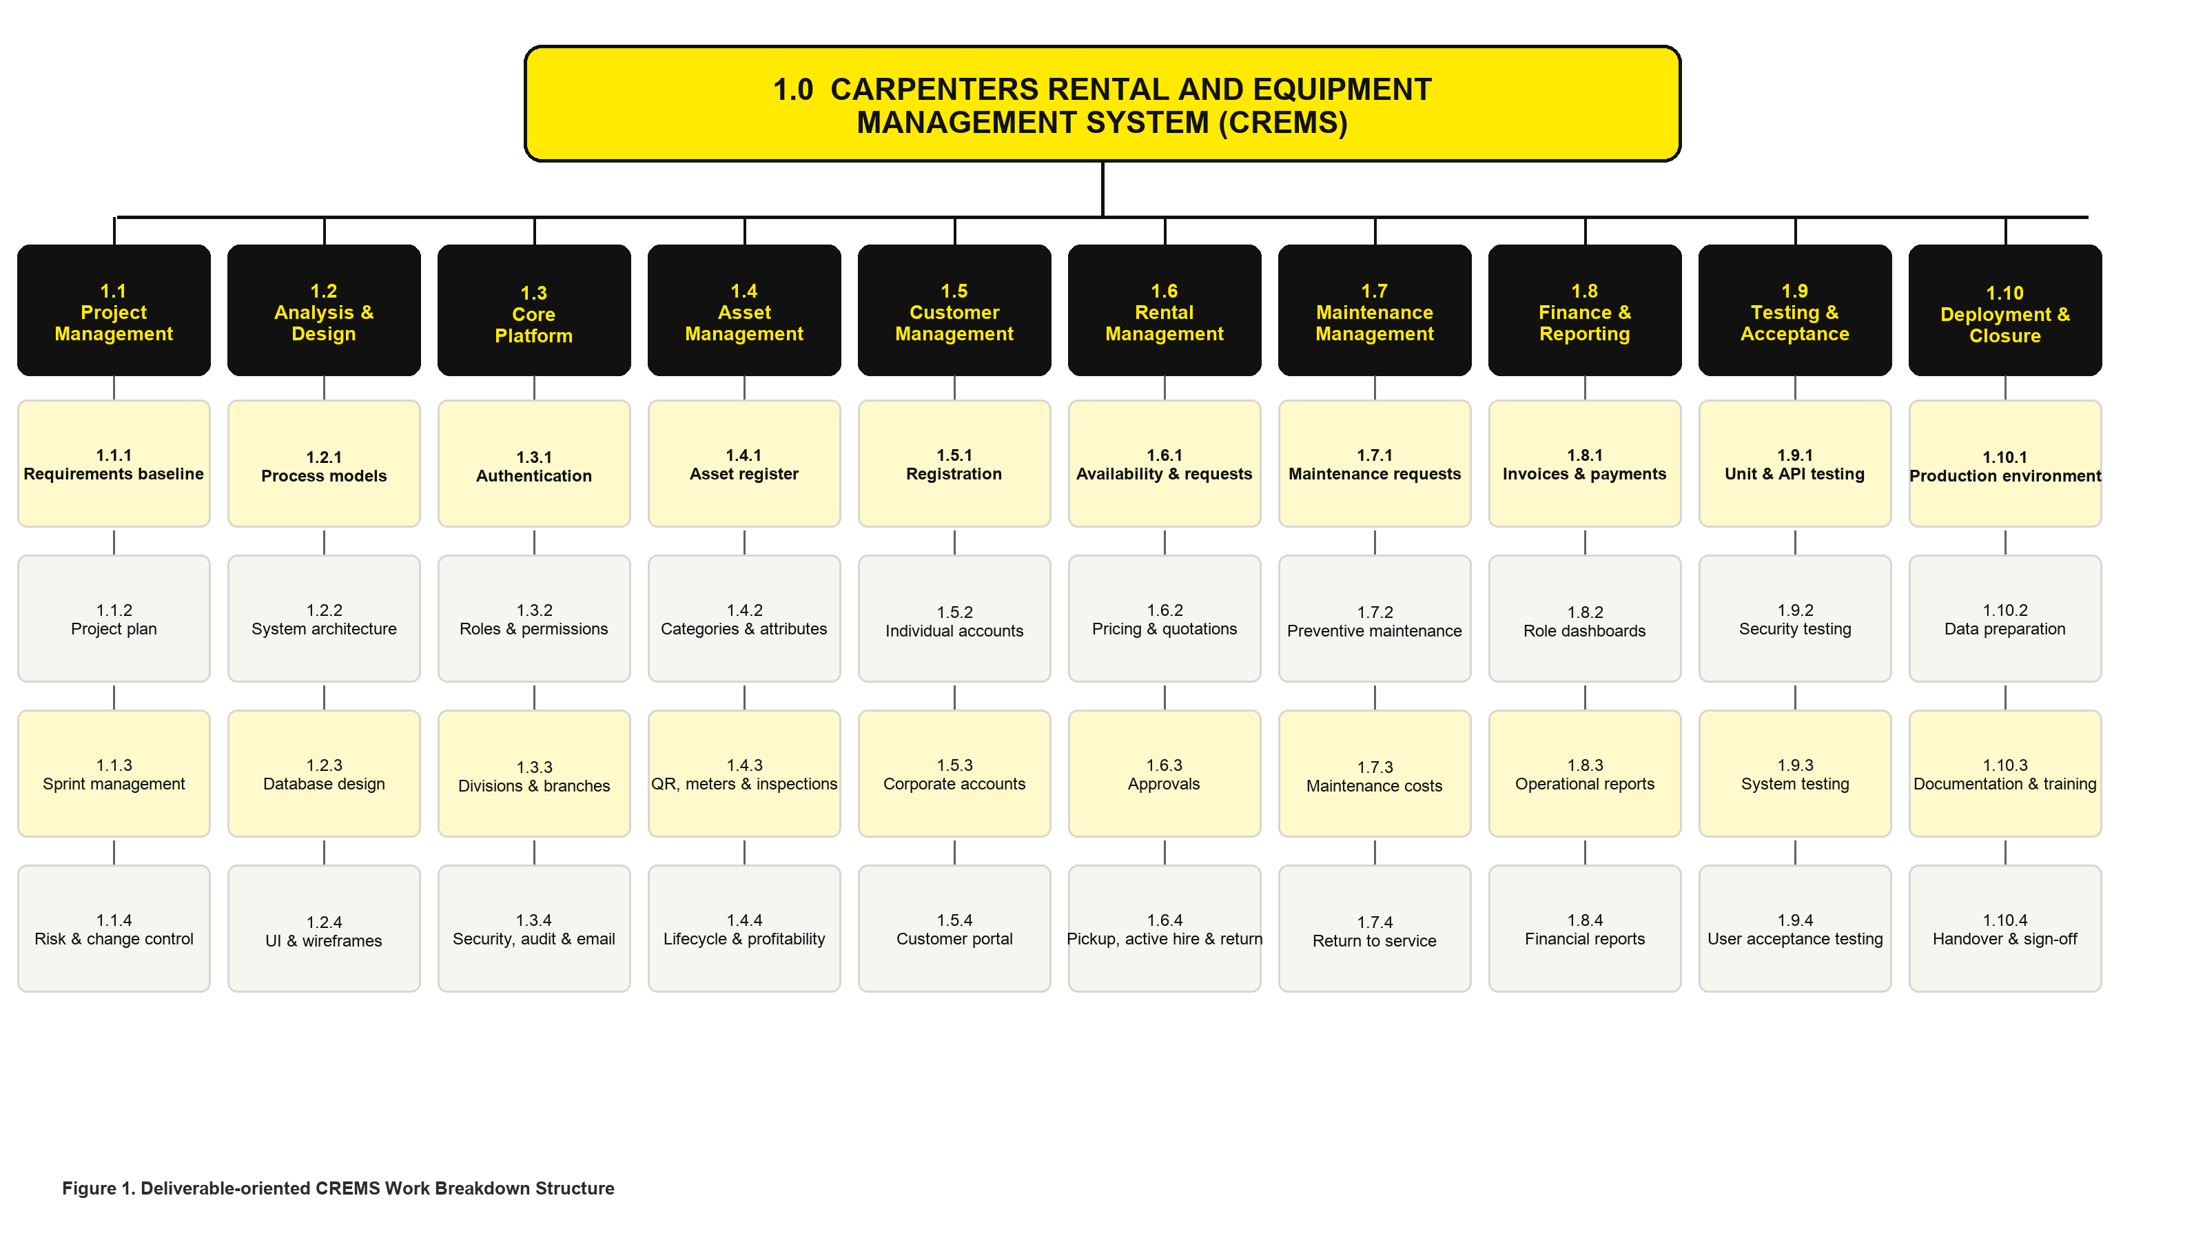

6.3 Weekly Sprint Cadence
Event | Timing | Purpose
Planning | Monday | Agree sprint goal, tasks, owners, acceptance criteria and risks
Team checkpoint | At least twice weekly | Surface blockers, integrate work and update board
Client clarification | As agreed, / when required | Resolve business questions without inventing policy
Code/ design review | Before merge | Check correctness, security, maintainability and consistency
Sprint review and demo | Friday | Show working evidence or completed planning artifact
Retrospective | After review | Record one or two improvements for the next sprint. [9]

7.0 Change Management Plan
"The purpose of this change management process is to manage change requests so that approved changes will be controlled, ensuring the project remains on schedule, within budget and provides the agreed deliverables." [18]

7.1 Change Request Form
Refer to the 17.1 Appendix A to view the change request form.

8.0 Communications Management Plan
This plan defines the communication requirements for CREMS and how information is distributed to ensure project success. The project leader takes the lead role in ensuring effective communications; the matrix below defines what is communicated, how often, in what format, and to whom.
Forum | Frequency | Participants | Output
Team coordination | Twice weekly | Four students | Progress, next actions, blockers, and workload.
Sprint planning / review | Weekly | Team; client when available | Goal, demonstration, feedback and accepted work.
Client checkpoint | weekly or as agreed | Team, client | Decisions clarified rules, and acceptance notes.
Supervisor update | As scheduled | Team and academic supervisor | Academic guidance and escalations.
Risk / scope review | Weekly | Whole team | Updated risks, decisions, and mitigations.

8.1 Project Team Directory
Name | Role | Contact
Kavish Chandra | Project Leader / Client Liaison | s11219143@student.usp.ac.fj
Shoneel Kumar | Backend and Data Lead | s11219651@student.usp.ac.fj
Sudhansu Kisun | Frontend and UX Lead | s11219520@student.usp.ac.fj
Rahul Chand | Quality and DevOps Lead | s11219885@student.usp.ac.fj
Dr Ravneil Nand | Academic Supervisor | ravneil.nand@usp.ac.fj
Mr Amit Kumar | Project Supervisor (Client) | amit.it@carpenters.com.fj
Mr Shanil Naidu | Project Co-Supervisor (Client) | shanil.it@carpenters.com.fj
Mr Ajnesh Prasad | Project Lead (Client) | p.ajnesh.it@carpenters.com.fj
Mr Rakitesh Kumar | Project Lead (Client) | rakitesh.it@carpenters.com.fj
Ms Sheetal Chand | Business Analyst (Client) | sheetal.it@carpenters.com.fj

8.2 Communications Conduct
- Meetings:
- Writing meeting notes.
- Meeting minutes are sent to the client to get endorsement.
- Email:
- Professional, error-free and addressed formally
- When reporting a problem, we will include the issue, the background, and our suggested solution.
- Informal communication:
- Any issue, concern, or update raised informally must be communicated to the project leader, so appropriate action can be taken.

9.0 Cost Management Plan
The Cost Management Plan describes the process of estimation, budgeting, monitoring and control of costs in the 12-week period of delivery (10 August - 30 October 2026). As a student effort is not invoiced by CREMS, cost management within CREMS project is intended to be minimalistic and cash-oriented: it includes control of few cash expenses (hosting, email sending, domain/TLS certificate) rather than a comprehensive budget taking into account effort-related costs, however still following the established approach to cost management (basis of cost estimate, baseline, thresholds, variances, reporting) in order to apply it in case of a business project.
Besides a cash-based cost management, cost management in CREMS also includes a non-cash aspect control of effort versus WBS to see if four-persons' limitation is maintained sprint after sprint.

9.1 Cost Baseline
Student labor, laptops and the tools we already have are our own contribution, Carpenters Fiji isn't charged for any of that. This section is about a small handful of things that could cost real money.
Here's the short version: everything we need to build CREMS is free from the coding tools, the database, and our own laptops. The only costs that could ever show up are three optional extras we might need for the last few weeks of testing with the client, plus a small buffer just in case. Worst case, the whole project costs FJD 170. Most likely, it costs nothing at all.
What it's for | In plain English | Most likely cost | Cost if we ever need it
Coding tools and software | The programs we build with all free, student or open-source versions. | FJD 0 | FJD 0
Database and test setup | Run on our own laptops at no extra cost. | FJD 0 | FJD 0
A practice website for the client to test on | We'll use a free trial website first and only pay if it needs to run more reliably for the final demo. | FJD 0 | up to FJD 60 [1]
Sending real test emails | Booking confirmations and password-reset emails are free to test; a small monthly fee only kicks in if we send from a real account near the end. | FJD 0 | up to FJD 45 [2]
A web address and secure padlock (TLS) | We'd rather use a free Carpenters Fiji or university web address. A standalone one would be a small yearly fee. The padlock/HTTPS itself is always free. | FJD 0 | up to FJD 35 [3], [4]
A safety buffer | Held back in case something genuinely unexpected comes up, nobody touches it without the team agreeing first. | FJD 0 | FJD 30
TOTAL | What this could cost Carpenters Fiji, worst case. | FJD 0 | FJD 170

9.2 Cost Reporting and Roles
Role | Cost responsibility
Project lead (Kavish Chandra) | Owns the cost register, approves cash purchases within the green band, and raises any Amber/Red variance at the weekly risk/change review.
Architecture/database lead (Sudhansu Jayshil Kisun) | Estimates and reports any hosting, database or infrastructure cost implication before a technical decision is committed
All team members | Record any cost-incurring action (even a free-tier sign-up that could later convert to paid) in the cost log at the point of commitment, not retrospectively
Client | Approves any spend that would draw on client-provided resources or exceed the planning allowance
Academic supervisor | Consulted where a cost decision affects assessment scope or academic timeline.

10.0 Procurement Management Plan
CREMS has minimal procurement requirements. The tech stack (React, ASP.NET Core, SQL Server Developer edition, Docker, GitHub, Postman and supporting libraries) is all either open-source or falls into free tiers or already paid for by the students/developers, so there is no procurement process required for the delivery of this product.
In those cases, where the purchase of an additional cash component is required, such as temporary hosting services or test email/domain limits. The project lead has the authority to agree to the cash ceiling budget stated in the Cost Baseline document. In any case where a purchase is required that goes above this ceiling or which provides a production service (such as hosting, payment or email/domain services), written permission must first be gained from the client (sponsor).

11.0 Project Scope Management Plan
Scope is measured and verified through sprint demonstrations, UAT scenarios, and the reconciliation checks described in the Quality Management Plan.
- Proposed scope changes may be initiated by the project leader, any team member, or the client, and are submitted through the change control process.
- The project leader evaluates each request.
- Any changes will require client approval before implementation, and the academic supervisor will be informed if the academic timeline is affected.
- The client is responsible for formally accepting the project's final deliverable, based on UAT results, testing evidence, and completion of the agreed work packages. [8]

12.0 Schedule Management Plan
Schedule Management Plan documents how the 12 weekly sprint schedules will be developed, sequenced, baselined, tracked and controlled, using an Agile time-boxed approach appropriate to the fixed 12-week academic window and four-person team.

12.1 Scheduling Methodology and Tools
Element | Approach
Methodology | Agile, fixed-length (one-week) sprints with a rolling backlog, rather than a fixed-scope critical-path schedule is chosen because requirements are expected to be changed through client feedback.
Scheduling unit | Sprint (1 week) is the primary planning unit; within a sprint, tasks are tracked at the work-package/task-board level rather than as a detailed Gantt of individual hours.
Tooling | Shared task board linked to the Git repository for day-to-day tracking; the sprint table serves as the master schedule baseline document.
Dependency management | Sequencing follows the dependency-aware order (e.g. authentication before organization/branch management before asset module) rather than a formal critical-path network diagram, given the sprint-boxed structure. [9]

12.2 Schedule Development
The task list is generated straight from the Work Breakdown Structure: every WBS work package gets split up into sprintable tasks and assigned to a sprint which respects the corresponding technical dependencies. This twelve-sprint schedule becomes the schedule baseline for this plan, whose primary scheduling principles are as follows:
- Sprint #1 is a combination of scope confirmation and minimal common engineering baseline (repository, initial database baseline), such that everything else has something to build on in the coming sprints.
- Authentication and common system services immediately follow scope confirmation (Sprint #2) because nearly every future module requires a proven authentication layer to work properly.
- Division/Branch/Role administration (Sprint #3) precedes the development of asset, booking, and inspection modules (Sprints 4–8) because those modules require proven isolation by access first.
- Two division-specific lifecycle demonstrations (motors, Sprint #8; carptrac, Sprint #10) are intentionally spaced by two sprints to leverage the first division's configuration model for reuse and testing rather than duplication.
- The final two sprints (Sprints #11-#12) are reserved for integration and stabilization purposes and will not accommodate slipped functionality features.

13.0 Quality Management Plan
Quality Management Plan extends the test approach to the quality policy, according to which CREMS quality is defined as a characteristic of meeting its acceptance criteria and having no open critical issues. The concept of MVP completion is used as the project’s quality gate.

13.1 Quality Metrics
Metric | Target | Measurement method
Must-requirement test pass rate | 100% of Must requirements have a passing acceptance test before the requirement is marked done | Traceability Matrix cross-checked against test results at each sprint review
Critical/high defect count at release | Zero unresolved critical/high defects at each milestone demo; none at final handover | Defect register reviewed at sprint review.
Cross-division/branch data leakage | Zero instances in API integration testing | Authorization test suite covering role/division/branch scenarios.
Performance — ordinary interactions | 95% of ordinary page/API interactions complete within 2 seconds on the test network for the agreed pilot dataset | Timed API/page checks against representative pilot data.
Performance — reports | Reports complete within 5 seconds where practical | Timed checks on report endpoints using pilot dataset
Usability — unaided task completion | At least 80% task completion in moderated UAT without facilitator intervention, for defined core tasks | Moderated UAT sessions with representative users.
Documentation quality | A team member who did not write the setup guide can complete setup successfully without undocumented steps | Clean-machine setup rehearsal.
Code review coverage | No production-like merge without at least one peer review | Pull-request review record in the Git history.
[14]

13.2 Quality Assurance Activities (Process-Focused)
Quality assurance activities are preventive — they aim to stop defects entering the product — and run continuously across the twelve sprints:
QA activity | Frequency | Purpose
Requirements review and acceptance-criteria definition | At scope baseline and whenever a requirement changes | Ensures every Must requirement is testable before development starts.
Peer code/design review before merge | Every merge to the protected main branch | Checks correctness, security, maintainability, and consistency.
Secure-configuration and dependency review | Each sprint | Confirms no secrets are committed and dependencies are free of known critical vulnerabilities
Migration apply/rollback rehearsal | Whenever a database migration is introduced | Confirms that a clean database can be created, and the upgrade path is documented.
Documentation-alongside-code discipline | Every feature | Migration and API documentation are updated as part of the definition of done, not deferred to Week 12
[10], [13], [16]

13.3 Quality Control Activities (Product-Focused)
Quality control activities are detective; they verify the delivered product meets its acceptance criteria and map directly to the test-strategy table already defined in PMP Section 16:
QC activity | Scope | Exit threshold
Unit testing | Pricing, status transitions, availability and profitability calculations | All critical business-rule tests pass
API integration testing | Authentication, authorization, validation, database transactions, error contracts | All critical API scenarios pass; no cross-division/branch leakage
Browser end-to-end testing | Customer booking journey and staff asset lifecycle (Motors and Carptrac scenarios) | Critical paths pass on agreed Chrome/Edge versions
Security testing | Session timeout, CSRF protection, access control, rate limiting, file-upload validation, dependency scan | No open critical/high issue without sponsor-approved treatment
Performance testing | Representative pilot dataset, timed API/page checks | Meets the 2-second/5-second targets.
Usability / UAT | Moderated sessions with representative users on defined core tasks | ≥ 80% unaided completion; feedback triaged into the backlog
[[10], [13], [14]

14.0 Risk Management Plan
Risks are reviewed weekly and after every client decision. The most likely and highest-impact risks are reflected in the sprint schedule so that mitigation actions are taken at the appropriate time, and risk owners provide status updates at team coordination meetings.
At project closure, the project leader will analyze each risk and the risk-management process itself, capturing improvements as lessons learned for future group projects. [15]

14.1 Risk Management Approach
- Risk identification is continuous: any team member, the client or the supervisor may raise a risk at any time; it is not limited to the weekly review.
- Each risk is scored for Probability (1–5) and Impact (1–5) and rated using the Probability × Impact matrix.
- Every risk has a single named member accountable for monitoring its triggers and executing its mitigation actions. Group (“All”) is used only where the risk is genuinely team wide.
- A risk that has already occurred is closed on the register and moved to the issue log, then handled through the change-control process of the Project Management Plan. [15]

14.2 Risk Register
ID | Category | Risk / Trigger | Score  (Rating) | Response | Mitigation Actions | Contingency | Team
R1 | Scope & Requirements | Requirements remain unclear or expand across divisions | 4×5=20  High | Mitigate | Baseline MVP and exclusions; decision log; prototypes; formal change control. | Freeze scope at the last approved baseline; defer new items to a post-MVP backlog. | Kavish
R2 | Stakeholder & Client | Limited client/user availability delays validation | 4×4=16  High | Mitigate | Book reviews early; send focused questions; document assumptions and expiry dates. | Proceed on the documented assumption with an expiry date; flag as an open decision. | Kavish
R3 | Resource & Schedule | Twelve-week scope exceeds four-person capacity | 4×5=20  High | Mitigate | Must/Should/Could priorities; vertical slices; protect testing/closure weeks. | Descope Should/Could items first; the Shipping-scope module is the first candidate for reduction. | All
R4 | Security & Data | Division/branch data leaks through weak authorization | 3×5=15  High | Mitigate | API-level policies, query scoping, isolation tests, peer security review. | Emergency hotfix; disable the affected endpoint until resolved. | Jayshil
R5 | Technical & Quality | Conflicting bookings or invalid asset status | 3×5=15  High | Mitigate | Transactional conflict checks, status rules, and concurrency tests. | Manual reconciliation procedure and booking-conflict alert until the fix is verified. | Shoneel
R6 | Quality & Technical | Incorrect pricing/profit calculations undermine trust | 3×5=15  High | Mitigate | Approved examples, decimal arithmetic, traceable line items, and calculation tests. | Freeze the affected calculation, notify users, and re-verify client examples before release. | Jayshil
R7 | Security & Data | Inspection photos/signatures create privacy/storage risk | 3×4=12  Med | Mitigate | Restricted types/sizes, private storage design, authorization and retention rules. | Restrict access/downloads pending fix; purge any non-compliant files. | Rahul
R8 | Technical & Operational | Team environment differences block integration | 3×3=9  Med | Mitigate | Docker/setup guide, pinned versions, clean-machine validation and shared config example. | Pair-fix on a clean machine and update the setup guide the same day. | Jayshil
R9 | External & Vendor | Email provider/domain is not ready | 3×3=9  Med | Mitigate | Sandbox testing, provider abstraction, queue/log, controlled fallback evidence. | Fall back to logged/sandbox delivery for demos; delay production sending until ready. | Rahul
R10 | Technical & Operational | Data loss or destructive migration | 2×5=10  Med | Mitigate | Versioned migrations, backups, restore rehearsal and non-production test first. | Restore from the last verified backup using the rehearsed restore procedure. | Jayshil
R11 | Resource & Team | Team availability or uneven workload | 3×4=12  Med | Mitigate | Small reviewed tasks, shared ownership, weekly rebalancing, and early escalation. | Redistribute tasks at the next checkpoint; escalate to the supervisor if unresolved after a week. | All
R12 | Quality & Schedule | UAT discovers major workflow mismatch late | 3×5=15  High | Mitigate | Weekly demonstrations, end-to-end prototypes, and acceptance criteria from Week 2. | Triage by requirement priority; fix Must-defects before handover, document limitations for Should/Could. | All
R13 | Resource & Academic | Coursework/exams in other CS400-concurrent papers reduce available hours in Weeks 9–11 | 3×4=12  Med | Mitigate | Share academic calendars early; plan a lighter individual load during clash weeks; buffer in Week 12. | Reprioritize the backlog to Must-only for the clash week; extend a work package within the sprint. | All
R14 | Financial & Budget | Planning budget (max FJD 580) exceeded by staging, email or domain costs | 2×3=6  Low | Accept | Cost log maintained by the project lead; free-tier default; spend requires team and client/academic approval. | Revert to the free tier resource or pause the paid service until further approval is obtained. | Kavish
R15 | Academic & Compliance | Client-provided sample data contains real personal or financial information, breaching confidentiality terms | 2×5=10  Med | Avoid | Data-minimization review before importing; prefer synthetic data; confidentiality clause enforced per document control. | Immediately quarantine and delete the dataset from all environments; notify client and supervisor. | Jayshil
R16 | Resource & Technical | Architecture/security knowledge concentrated in one team member (bus factor) | 3×4=12  Med | Mitigate | Architecture decision records, knowledge sharing sessions, mandatory peer review on core modules. | Run an emergency knowledge transfer session; temporarily pair remaining members on the affected module. | Jayshil
R17 | Scope & Stakeholder | Conflicting priorities requested by different division stakeholders (Motors vs Carptrac vs Shipping) | 3×4=12  Med | Mitigate | Single prioritized backlog; client sponsor arbitrates conflicts; Must/Should/Could framework applied consistently. | Escalate the unresolved conflict to the client sponsor for a binding decision within one business day. | Kavish
R18 | Operational | Hardware failure, device loss or corrupted local environment causes lost work | 2×3=6  Low | Mitigate | Git remote as source of truth; frequent commits/pushes; cloud-stored documentation; Dockerized environment. | Rebuild the environment from the repository and setup guide on a spare device; restore docs from cloud copy. | All
R19 | Technical & Security | Third-party/open-source package vulnerability or breaking update disrupts the build | 2×3=6  Low | Mitigate | Dependency scanning, pinned package versions, review before upgrading. | Roll back to the last known-good version; patch or replace the affected package before the next release. | Jayshil
R20 | Schedule & Stakeholder | Client or supervisor sign-off on a milestone (e.g., M1 scope baseline, M2 design) is delayed | 3×4=12  Med | Mitigate | Schedule reviews early in the sprint; default to a documented assumption after the agreed response window. | Proceed on the documented assumption; formally supersede once approval is received. | Kavish
R21 | Quality & Testing | Automated test coverage on critical business rules (pricing, availability, RBAC) falls behind under schedule pressure | 3×4=12  Med | Mitigate | Critical-path tests defined at design stage; tests required in the Definition of Done; peer review gate. | Halt new feature work on the affected module until critical tests are restored. | Rahul
R22 | Security & Data | Session/cookie security misconfiguration exposes user accounts | 2×5=10  Med | Mitigate | Security checklist from the NFR baseline; peer security review; automated configuration verification test. | Force session invalidation and password reset for affected accounts; hotfix under the emergency change process. | Jayshil
R23 | External & Operational | Staging/demo environment approval from client or institution IT is delayed, blocking integrated demos and UAT | 3×4=12  Med | Mitigate | Request staging approval by Week 2–3; document environment requirements to expedite approval. | Demonstrate the local/dev environment and reschedule staging-dependent UAT once approved. | Jayshil
R24 | Academic & Compliance | AI-assisted content is used without required disclosure, breaching CS400 academic-integrity policy | 2×4=8  Med | Avoid | AI-use declaration maintained in document control; team reviews and rewrites AI-assisted content; usage logged per course policy. | Correct and re-declare the affected submission immediately; consult the supervisor on required remediation.
[15]

14.3 Top Risks Summary
7 risks currently carry a high rating (score 15–25) and receive priority attention at every weekly review:
ID | Risk | Score | Response focus | Team
R1 | Requirements remain unclear or expand across divisions | 4×5=20 | Baseline MVP and exclusions; decision log; prototypes; formal change control. | Kavish
R3 | Twelve-week scope exceeds four-person capacity | 4×5=20 | Must/Should/Could priorities; vertical slices; protect testing/closure weeks. | All
R2 | Limited client/user availability delays validation | 4×4=16 | Book reviews early; send focused questions; document assumptions and expiry dates. | Kavish
R4 | Division/branch data leaks through weak authorization | 3×5=15 | API-level policies, query scoping, isolation tests, peer security review. | Sudhansu
R5 | Conflicting bookings or invalid asset status | 3×5=15 | Transactional conflict checks, status rules and concurrency tests. | Shoneel
R6 | Incorrect pricing/profit calculations undermine trust | 3×5=15 | Approved examples, decimal arithmetic, traceable line items, and calculation tests. | Sudhansu
R12 | UAT discovers major workflow mismatch late | 3×5=15 | Weekly demonstrations, end-to-end prototypes and acceptance criteria from Week 2. | All

15. Resource Calendar
All four team members are required for the full duration of the twelve-week programme (10 August – 30 October 2026), at an assumed 6 and 1/2 hours per person per week, giving a planned team effort of 312 hours (4 people × 6.5 hours × 12 weeks). Levels of effort will vary from week to week. If a member is not needed for a full week at any point, their time outside CREMS remains at their own discretion, balanced against other coursework.

15.1 Human Resources
Project Role | Assigned Person | Responsibilities | Effort
Project Leader / Client Liaison | Kavish Chandra | Plan, meetings, scope/decision control, integration, submission, and team coordination. | 6.5 h/week
Backend and Data Lead | Shoneel Kumar | Domain/API/database, authorization, migrations, backend tests and security. | 6.5 h/week
Frontend and UX Lead | Sudhansu Kisun | Responsive journeys, accessibility, API integration, UI testing, and user help. | 6.5 h/week
Quality and DevOps Lead | Rahul Chand | Test plan/evidence, Docker/builds, release, backup, documentation, and demonstrations. | 6.5 h/week

15.2 Technical and Information Resources
- Four development laptops (mixed macOS/Windows).
- GitHub repository with issues, feature branches, pull requests and version history.
- .NET 10 SDK, Node.js 22+, React, Material UI, SQL Server 2022, Docker Desktop, VS Code and Postman.
- Client representatives, current forms/agreements, sample asset categories, and branch/division information.
- Academic supervisors for assessment guidance. [11], [12], [17]

16.0 Reference
[1] Render, Inc., "Pricing," Render. [Online]. Available: https://render.com/pricing. [Accessed: Aug. 13, 2026]
[2] Twilio Inc., "Email API Pricing," Twilio SendGrid. [Online]. Available: https://www.twilio.com/en-us/products/email-api/pricing. [Accessed: Aug. 13, 2026]
[3] Namecheap, Inc., "Domain Name Prices — Domain Registration Costs," Namecheap. [Online]. Available: https://www.namecheap.com/domains/. [Accessed: Aug. 13, 2026]
[4] Internet Security Research Group, "Frequently Asked Questions," Let's Encrypt. [Online]. Available: https://letsencrypt.org/docs/faq/. [Accessed: Aug. 13, 2026]
[5] Microsoft Corp., "Editions and Supported Features of SQL Server 2022," Microsoft Learn. [Online]. Available: https://learn.microsoft.com/en-us/sql/sql-server/editions-and-components-of-sql-server-2022. [Accessed: Aug. 13, 2026]
[6] Docker Inc., "Docker Desktop License Agreement," Docker Docs. [Online]. Available: https://docs.docker.com/subscription/desktop-license/. [Accessed: Aug. 13, 2026]
[7] Xe, "USD to FJD — US Dollar to Fijian Dollar Exchange Rate," Xe.com. [Online]. Available: https://www.xe.com/currencyconverter/convert/?Amount=1&From=USD&To=FJD. [Accessed: Aug. 13, 2026]
[8] Project Management Institute, A Guide to the Project Management Body of Knowledge (PMBOK® Guide), 7th ed. Newtown Square, PA, USA: PMI, 2021.
[9] K. Schwaber and J. Sutherland, "The Scrum Guide: The Definitive Guide to Scrum: The Rules of the Game," Scrum.org, 2020. [Online]. Available: https://scrumguides.org/docs/scrumguide/v2020/2020-Scrum-Guide-US.pdf. [Accessed: Aug. 13, 2026].
[10] I. Sommerville, Software Engineering, 10th ed. Boston, MA, USA: Pearson, 2016.
[11] Microsoft Corp., "ASP.NET Core Documentation," Microsoft Learn. [Online]. Available: https://learn.microsoft.com/aspnet/core. [Accessed: Aug. 13, 2026].
[12] Microsoft Corp., "Entity Framework Core Documentation," Microsoft Learn. [Online]. Available: https://learn.microsoft.com/ef/core. [Accessed: Aug. 13, 2026].
[13] OWASP Foundation, "OWASP Top 10: The Ten Most Critical Web Application Security Risks," OWASP. [Online]. Available: https://owasp.org/www-project-top-ten/. [Accessed: Aug. 13, 2026].
[14] IEEE Computer Society, IEEE Standard for Software and System Test Documentation (IEEE Std 829-2008). New York, NY, USA: IEEE, 2008.
[15] International Organization for Standardization, ISO 31000:2018 Risk Management – Guidelines. Geneva, Switzerland: ISO, 2018.
[16] M. Fowler, Refactoring: Improving the Design of Existing Code, 2nd ed. Boston, MA, USA: Addison-Wesley, 2018.
[17] R. C. Martin, Clean Architecture: A Craftsman's Guide to Software Structure and Design. Boston, MA, USA: Prentice Hall, 2017.
[18] N. Thomas, "Change Management Process For Project," 2023.

17.0 Appendix

17.1 Appendix A
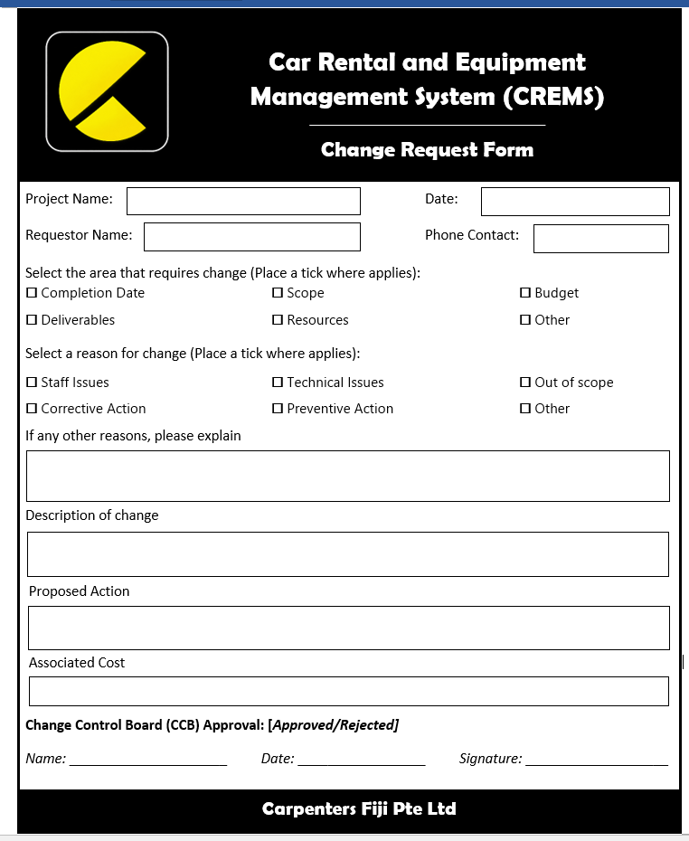

17.2 Appendix B
Use Case Diagram
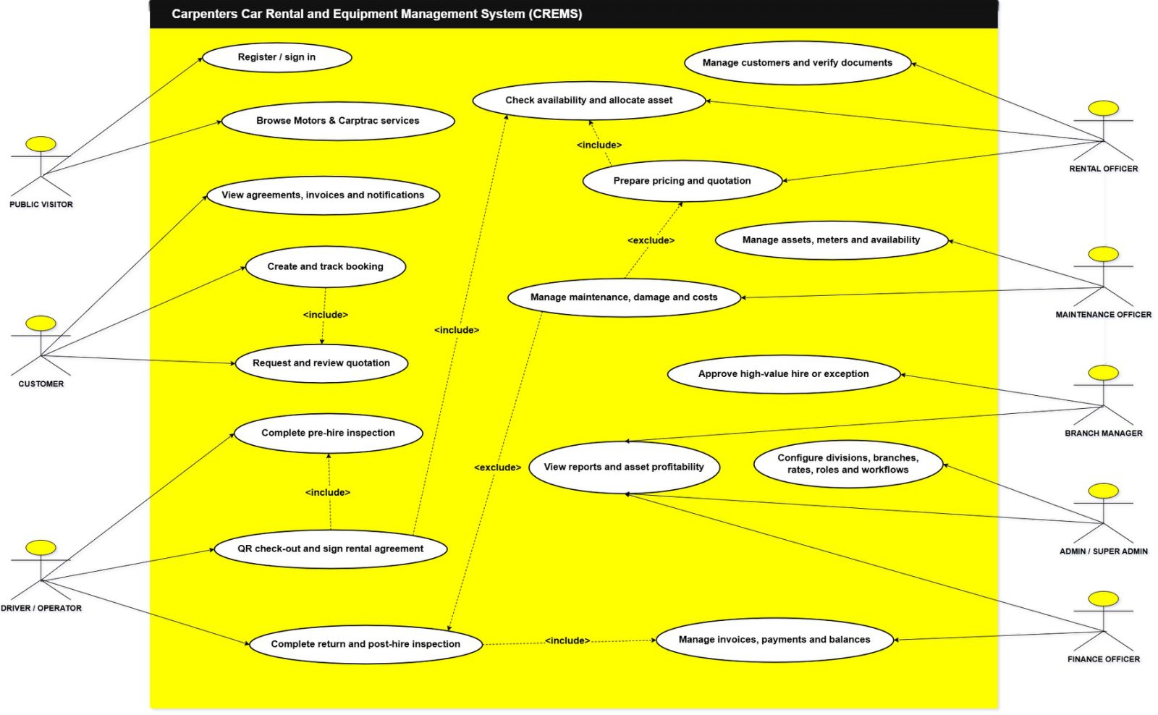

17.3 Appendix C
Data Flow Diagram (DFD) Level 0
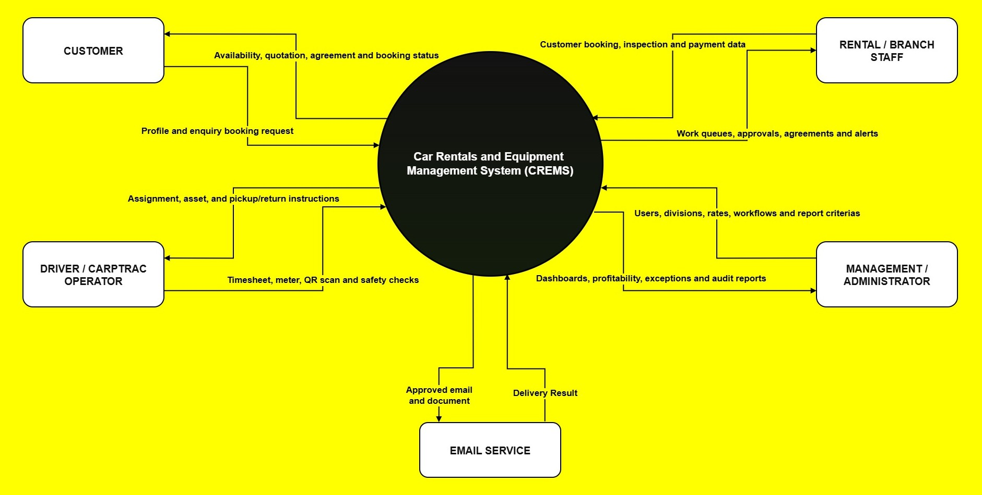

17.4 Appendix D
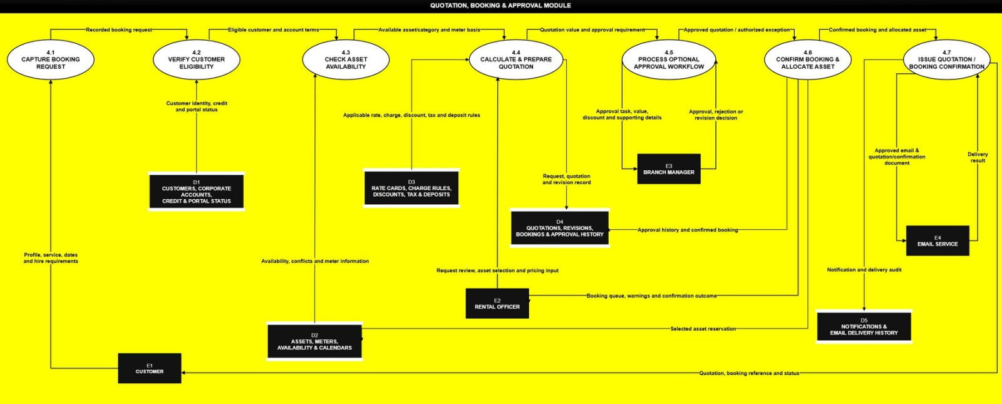
Quotation Booking & Approval Module DFD Level 1

17.6 Appendix F
Please find the ERD attached in the email.

18.0 Sponsor Acceptance

Approved by the Client Sponsor:
Signature: ______________________________ Date: ______________
Name: Amit Kumar
Title: Carpenters Fiji Pte Limited
Approved by the Academic Supervisor:
Signature: ______________________________ Date: ______________
Name: Ravneil Nand
Title: Academic Supervisor
Approved by the Project Leader:
Signature: ______________________________ Date: ______________
Name: Kavish Chandra

